Judicial Reverse Mentoring 2026 –Application Information for Mentors

Introduction and Overview
The Judicial Reverse Mentoring scheme (JRM) fosters greater judicial understanding of the experience of individuals from backgrounds currently underrepresented within the judiciary and the specific barriers they face in accessing a career in law and the judiciary. ​
Reverse mentoring challenges the idea of hierarchy by turning the traditional mentoring format on its head, with the younger or more junior colleague mentoring the senior leader. This process recognises that there are learning opportunities on both sides of a mentoring relationship, with significant benefit for both parties. Some reverse mentoring schemes, including this one, focus on sharing the experience of individuals from underrepresented groups. This scheme supports one of the core objectives of the Judicial Diversity and Inclusion Strategy:
“Every judicial office holder fosters an inclusive working environment where everyone is treated with dignity and respect”.
The annual cohort starts with a launch event to welcome participants and provide initial advice and suggestions on how to get the most out of the scheme. The focus of the scheme is six mentoring sessions between a judge (Mentee) and legal professional (Mentor). Once paired*, they arrange their sessions over the six to eight months duration of the scheme. Mentoring pairs are assisted throughout the scheme by facilitated networking and check in sessions, resources and guidance materials. Participants celebrate completing the programme with a closing event. The Judicial Diversity and Inclusion team, who manage the scheme, are also available to provide ad hoc support at any time during the scheme. See below for an overview of the scheme:
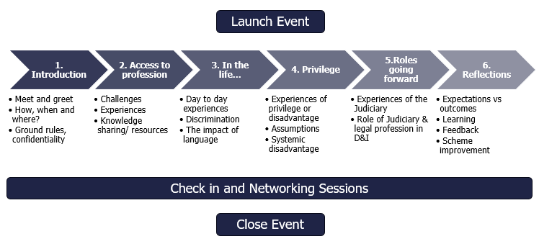
*We endeavour to match pairings so that the Mentor is unlikely to appear at the Mentee’s court or before the Mentee. However, it is not possible to guarantee this.

About you
The Mentor role on this scheme is open to currently practising legal professionals from backgrounds currently underrepresented within the judiciary who 10 years or fewer post qualification/call. This includes: individuals of Black, Asian and ethnic minority backgrounds, women, individuals with disabilities, members of the LGBTQ+ community and those from socio-economically disadvantaged backgrounds.
The scheme is aimed at those who would like to take part in making a positive impact on the judiciary by fostering a greater understanding of the experience of individuals from these underrepresented groups in accessing a career in law and in the judiciary. The scheme also enables you the opportunity to gain a greater understanding of the judiciary.
You will be expected to:
- Be conscientious in your approach to the arrangement, keep to agreed meeting times as far as possible, and commit to completing the six sessions by the end of the programme.
- Take the lead in discussions to support your mentee’s understanding of the experiences of underrepresented group(s) in the legal profession.
- Share your experiences and perceptions honestly and openly, treating anything discussed in confidence (your mentee will be expected to do the same).
- Deal tactfully and respectfully with any issues that are raised.
- Be open minded about what you can learn from the experience and engage with reflection at the end of the process.

Testimonials
Hear first-hand about the experiences of Mentor and Mentee pairs from previous cohorts:
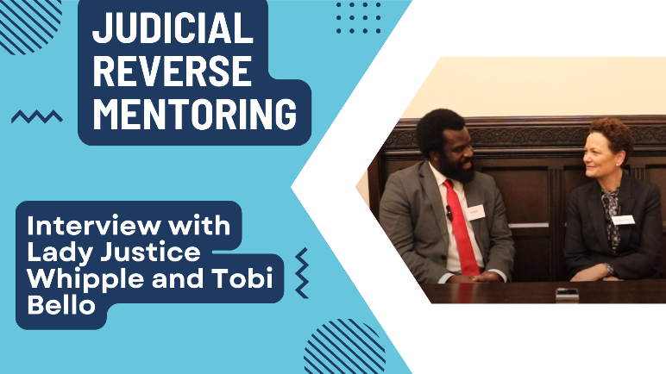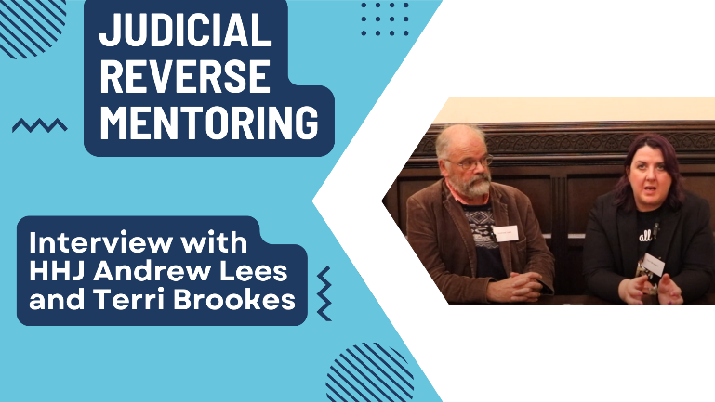
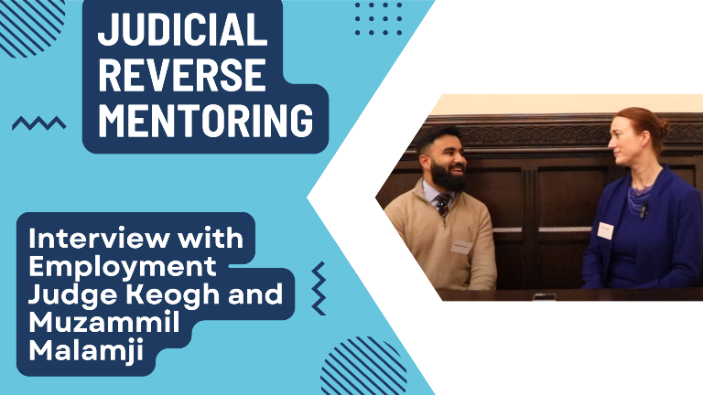

Application
If you are interested in applying to be a Mentor for the 2026 cohort of the Judicial Reverse Mentoring scheme, please complete and submit your application on the Judicial Careers Portal.
The deadline for applications is midnight on Tuesday 24 March 2026.
If you have any queries, concerns or issues, please contact JudicialReverseMentoring@judiciary.uk
Following submission of an application, should you wish to withdraw as a mentor, please inform the Judicial Diversity and Inclusion Team on the email above at the earliest possible.

