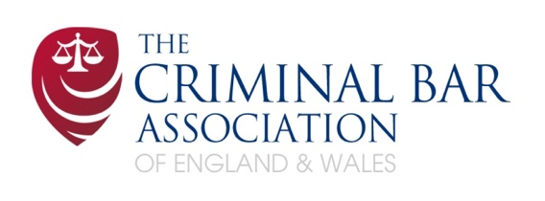

Criminal Bar Association Advocacy Training Award

The South Eastern Circuit, Tim Dutton CBE KC, Advanced International Advocacy Course
Keble College, Oxford 2026

This application form is to be used in order to apply for an award from The Criminal Bar Association toward the cost of the Advanced Advocacy Course at Keble College, Oxford from Tuesday 25th August – Saturday 29th August 2026. The award covers the cost of attending the course in full.

The CBA encourage applications from those in practice, undertaking publicly funded work in whole or in substantial part.

Applicants must:
- be a member of the association’
- currently practise as Barristers and hold current practising certificates
- have practised for at least three full years (not including pupillage) and no more than seven.

Applications will not be accepted from pupils or those in practice for less than three full years (“new practitioners”).

This completed application must be submitted together with the course application form directly to: The South Eastern Circuit by email: aaron.dolan@southeastcircuit.org.uk

CLOSING DATE THIS APPLICATION: 25th MAY 2026

All Information Provided will be treated in the strictest confidence

Section 1 - Personal details

Name

E-mail address

Chambers & address
Mobile telephone number

Section 2 - Professional details

Inn of Court

Date of Call
Are you a member of any of the circuits?
If so, please specify.

Is it your present intention to continue practising at the criminal Bar for the foreseeable future?

Please state why you feel you should obtain an award and how you will benefit from the course. (in no more than 100 words)

Please provide any further information which you feel may be relevant to the decision to grant you an award, e.g. your total debt, excluding mortgage. (in no more than 100 words)

What areas of your practice are remunerated from public funds?

What percentage of your time do you spend appearing in court or other tribunal when undertaking publicly funded work?

Section 3 – Financial Circumstances

Income

Is the majority of your practice spent in publicly funded work? (yes/no)

Does your Chambers / employer contribute toward the cost of attending Keble or provide any form of financial assistance including loans?

Referee name & contact details

Please provide details of a professional referee who may be contacted for a reference as part of this application process. This should be your Head of Chambers or Head of Publicly Funded Work at your chambers. Please include address and professional email address.

Declaration

I declare that I declare that the above particulars are true to the best of my knowledge and belief. Placing my signature below confirms the truth of this statement.

Signed:

Name:

Date:

